Acrylic AM system Leopard-I
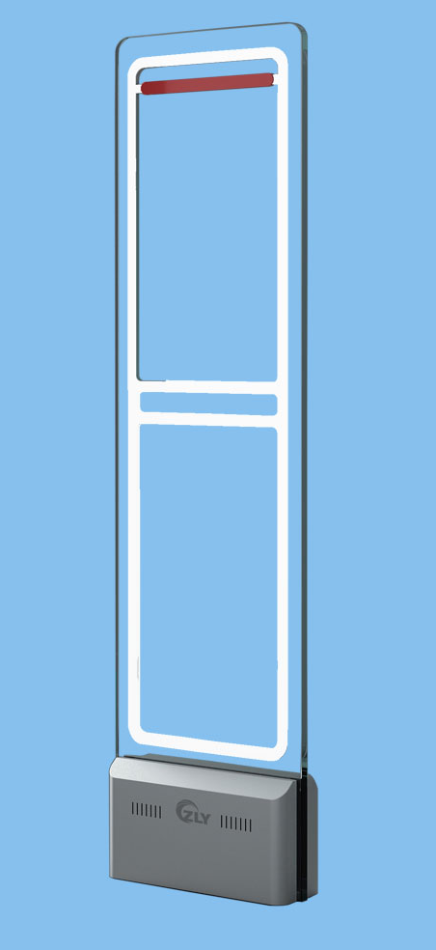
Description:
  - Novel appearance
  - ---Germany imported acrylic material, crystal clear appearance, beautiful and simple, fire-resistant, high temperature-resistant, never deformation.
  - Advanced technology---Leopard products adopt the world's leading signal acquisition and processing technology, use high-performance DSP system for signal analysis and detection, built-in super anti-jamming algorithm, strong environmental adaptability, almost no false positives.
  - Ultra wide protection---On the premise of avoiding false positives, both the soft labels and hard tags have a long detection distance. If using the Chinese Dr label , the effective distance on one side of the equipment can reach 80cm-90 cm, and the width of the channel is 1.6-1.8 meters.
  - Easy to debug---Providing the debugging tools based on Windows and Android App, using mobile phone App or PC through WIFI wireless debugging, simple and fast operation, remote real-time debugging can be realized through the cloud.
  - Simple configuration---The controller is built into the device. Easy to install, and generous appearance, plug and play, no external controller is required.
  - After-sales maintenance---Each main board has a unique global ID. The IDs are uploaded to the cloud in the factory, can remotely monitor the working status of the device. The main board is encrypted individually and unauthorized persons cannot debug it without authorization
  - Self Produce and Self Sell---We independent research and develop, produce and sale from the main board to the external antenna, the strict control of the quality ensure every set of the equipment is a boutique.
Configure & use:
  - Master Antenna: mono antenna with the independent controller function.
  - Vice Antenna: mono antenna with both the detection and alarm function.
  - Configuration 1：one master antenna can work with one vice antenna both of the antennas can alarm.
  - Configuration 2: one master antenna with one slave antenna, can be set to a dual system. One master antenna with two vice antennas, can be set to as a “RX+TX+RX” system.
Technical Parameters:
Leopard-I Technical Parameters:
Material | Acrylic
Size： | 1570*430*20(base:140)mm
Frequency： | 58kHz
Antenna weight: | Master23.8KG Slave:22.3KG
Input | 110-120VAc/220-240VAc, 1A 50-60HZ
Transmit pulse duration: | 1.6ms
Emission current: | 10A (peak)
Alarm duration: | 2S
Ambient temperature: | 0℃ to 35℃
Relative humidity: | 0 to 90%

Accessories and Protection Range:
Accessories: | Leopard-I protection range for one side | Leopard-I protection range for one channel
DR label | 800-900mm | 1600-1800mm
25 ferrite small pencil tag | 950-1050mm | 1900-2100mm
33 ferrite mid pencil tag | 1100-1200mm | 2200-2400mm
39 ferrite mid pencil tag | 1200-1300mm | 2400mm-2600mm
45 ferrite big pencil tag | 1400mm-1500mm | 2800mm-3000mm

